Addressing Dyslexia Toolkit - Professional Reflection and Planning Tool:  What is Dyslexia?  This professional reflection and planning tool support opportunities to reflect on your knowledge and understanding of the areas highlighted within the Addressing Dyslexia toolkit and help you plan the next steps in your professional learning. |  |  |  |  |  |  | 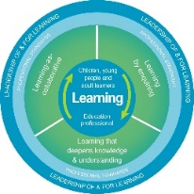
Name |  |  | Establishment |  |  | Date
Toolbox Focus area |  | My reflections on this section |  |  | My next steps and priorities for my professional learning.
Explanation of dyslexia and the associated difficulties

Films

Reflective Prompts | Next Steps and Priorities for my Professional Learning.
How does my understanding of dyslexia impact on my practice and how do I know?
How well does my school community ethos reflect an understanding of dyslexia and how do we know?

