Addressing Dyslexia Toolkit - Professional Reflection and Planning Tool:  Resources  This professional reflection and planning tool support opportunities to reflect on your knowledge and understanding of the areas highlighted within the Addressing Dyslexia toolkit and help you plan the next steps in your professional learning. |  |  |  |  |  |  | 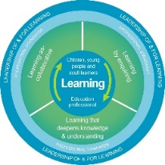
Name |  |  | Establishment |  |  | Date
Toolbox Focus area |  | My reflections on this section |  |  | My next steps and priorities for my professional learning.
Free templates and resources
Technology
Covid 19 Resources

Reflective Prompts | Next Steps and Priorities for my Professional Learning.
How effectively do I use the free resources and information to support learners and curriculum accessibility available on the Toolkit?
How do we know that colleagues and partners within our school community are aware of and access the resources to support curriculum accessibility available on the Toolkit?

