Addressing Dyslexia Toolkit - Professional Reflection and Planning Tool:  Assessing and Monitoring  This professional reflection and planning tool support opportunities to reflect on your knowledge and understanding of the areas highlighted within the Addressing Dyslexia toolkit and help you plan the next steps in your professional learning. |  |  |  |  |  |  | 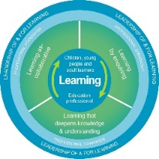
Name |  |  | Establishment |  |  | Date
Toolbox Focus area |  | My reflections on this section |  |  | My next steps and priorities for my professional learning.
Assessing and Monitoring
Roles and partnerships
Reporting
Planning and Monitoring

Reflective Prompts | Next Steps and Priorities for my Professional Learning.
How do I/could I contribute to the identification pathway?
How do I know my practice is collaborative and learner centred?

